**OPERATING**

**SYSTEM**

**LAB – 5**

**Crontab**

**(Simple Task Automation)**

**Submitted by: ~**

**Ayushi Kumari**

**RA1911003010865.**

1. **Schedule a task to display the following message on the monitor for every 2 minutes.**

Commands used are: -

* ls
* tty
* crontab -e
* In crontab terminal write: */2 * * * * echo Ayushi >> /dev/pts/6
* Use Ctrl + O to save and Enter and Ctrl + X to come out of the crontab.
* systemctl start cron

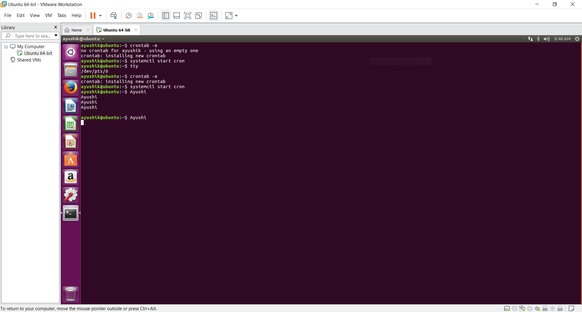

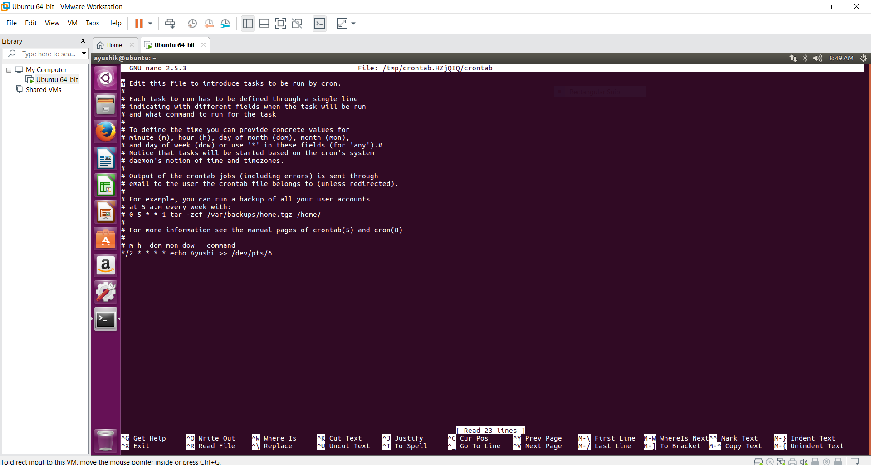

1. **Schedule a task to take backup of your important file (say file f1) for every 30 minutes.**

Commands used are-

* crontab –e
* In crontab terminal write: */30 * * * * cp f1 f5
* Use Ctrl + O to save and Enter and Ctrl + X to come out of the crontab.
* systemctl start cron

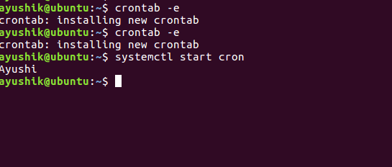

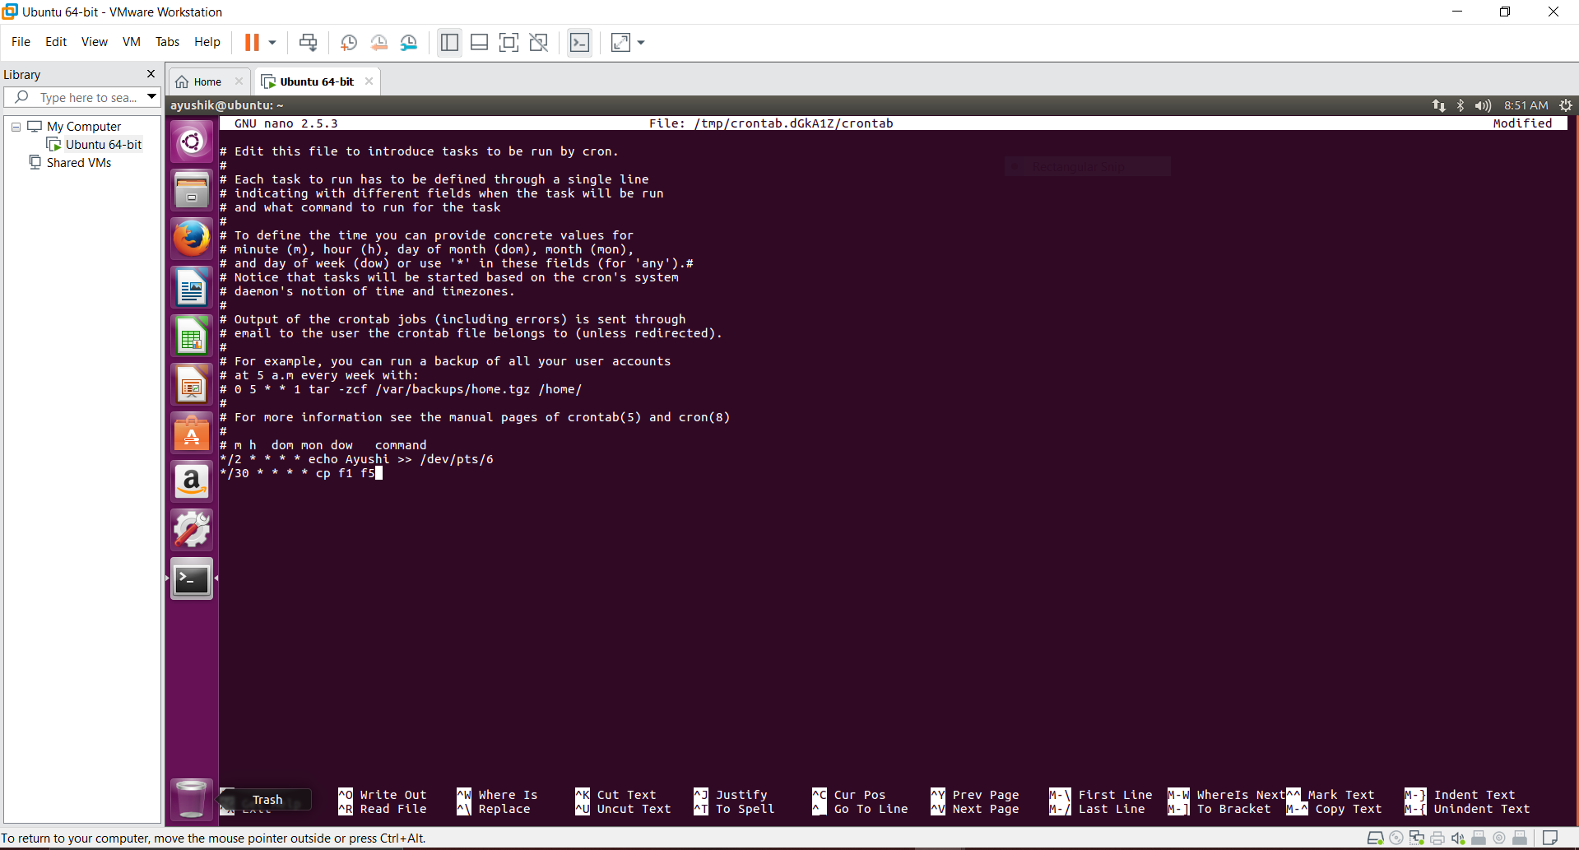

1. **Schedule a task to take backup of login information everyday 9:30 AM.**

Commands used are-

* crontab -e
* In crontab terminal write: 30 9 * * * cp /etc/passwd passwdback
* Use Ctrl + O to save and Enter and Ctrl + X to come out of the crontab.
* systemctl start cron

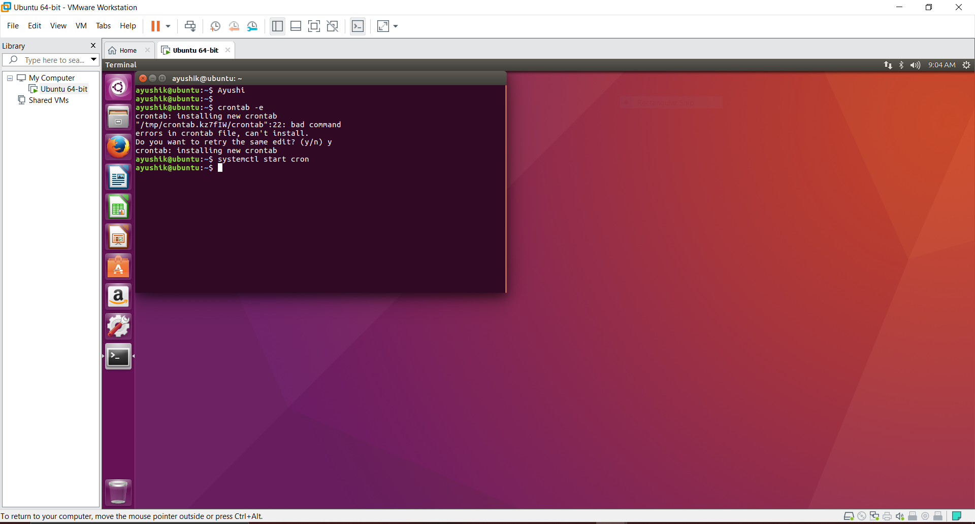

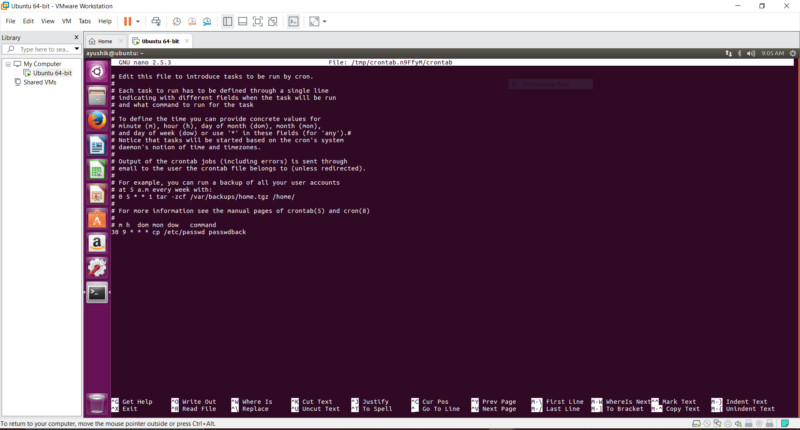

**-------------------------X---------------------------**